Here’s a **complete, in-depth explanation of Hadoop** in the context of **Parallel and Distributed Computing**, with architecture, components, examples, and use cases.

**Hadoop: Parallel & Distributed Computing**

**1. Definition of Hadoop**

**Hadoop** is an **open-source framework** for **distributed storage and parallel processing of large datasets** across clusters of computers using simple programming models.

**Exam-ready one-line definition:**

**Hadoop is an open-source framework that allows distributed storage and parallel processing of large datasets across clusters of computers in a fault-tolerant and scalable manner.**

**2. Why Hadoop is Needed**

Traditional computing problems:

* Data too large for a single machine
* Processing is slow
* Risk of hardware failure

Hadoop solves this by:

* **Distributing data across multiple machines**
* **Parallel processing** using multiple nodes
* **Fault tolerance** (replication of data)
* **Scalability** (add more nodes easily)

**3. Core Features of Hadoop**

1. **Scalability:** Can scale from single server to thousands of machines.
2. **Fault Tolerance:** Automatically replicates data.
3. **Cost-Effective:** Runs on commodity hardware.
4. **Flexibility:** Handles structured, semi-structured, and unstructured data.
5. **High Throughput:** Processes large data in parallel.

**4. Hadoop Architecture**

Hadoop has **two main layers**:

**4.1 HDFS (Hadoop Distributed File System)**

* Distributed file storage system.
* Splits files into **blocks** and stores them across cluster nodes.
* Each block is **replicated** for fault tolerance (default 3 copies).

**Components:**

* **NameNode:** Master node, stores metadata.
* **DataNode:** Slave nodes, store actual data.

**4.2 MapReduce**

* Parallel data processing framework.
* Processes large datasets **in parallel** on multiple nodes.

**Phases:**

1. **Map Phase:** Data is processed and transformed into key-value pairs.
2. **Shuffle & Sort:** Keys are grouped together.
3. **Reduce Phase:** Aggregation or computation on grouped keys.

**5. Hadoop Ecosystem Components**

| **Component** | **Role** |
| --- | --- |
| HDFS | Distributed storage |
| MapReduce | Distributed computation |
| YARN | Resource management & scheduling |
| Hive | SQL-like query on Hadoop |
| Pig | Script-based data processing |
| HBase | NoSQL database |
| Sqoop | Data transfer from RDBMS to Hadoop |
| Flume | Streaming data ingestion |
| Oozie | Workflow scheduler |

**6. How Hadoop Supports Parallel Computing**

* **Data is split into blocks** (default 128 MB).
* **Map tasks** run on different nodes simultaneously.
* **Reduce tasks** aggregate results.
* Maximum **CPU utilization** across cluster.

**Example: Word Count**

1. Input: Text files on HDFS
2. Map Phase: Count words in each block
3. Shuffle: Group same words
4. Reduce: Sum counts per word
5. Output: Final word count

**7. Hadoop Example (Simplified)**

**Data:**

File1: "apple banana apple"

File2: "banana apple orange"

**Map Output:**

("apple", 1), ("banana", 1), ("apple", 1)

("banana", 1), ("apple", 1), ("orange", 1)

**Shuffle & Sort:**

("apple", [1,1,1])

("banana", [1,1])

("orange", [1])

**Reduce Output:**

("apple", 3)

("banana", 2)

("orange", 1)

**8. Fault Tolerance in Hadoop**

* HDFS replicates blocks (default 3 times).
* NameNode tracks block locations.
* DataNode failures automatically handled.
* MapReduce tasks re-run if a node fails.

**9. Hadoop vs OpenStack / AWS / Globus / Condor**

| **Feature** | **Hadoop** | **OpenStack** | **AWS** | **Globus** | **Condor** |
| --- | --- | --- | --- | --- | --- |
| Type | Framework | Cloud platform | Cloud platform | Middleware | Job scheduler |
| Focus | Big Data storage & processing | Cloud infrastructure | Cloud services | Grid computing | High-throughput tasks |
| Parallelism | MapReduce tasks | VMs, containers | EC2, Lambda | Distributed tasks | Independent jobs |
| Distributed | Across cluster nodes | Across cloud nodes | Across regions/zones | Across grid nodes | Across idle machines |
| Fault Tolerance | Built-in replication & task re-run | Multi-zone | Multi-zone replication | Depends on middleware | Job migration & checkpointing |

**10. Real-World Use Cases**

* Facebook: Hive and HBase on Hadoop
* Yahoo: Log processing and analytics
* Amazon: Big data analytics
* Weather forecasting: Parallel processing of climate data
* Financial data analysis: Large-scale computations

**11. Advantages of Hadoop**

* Scalable to thousands of nodes
* Cost-effective (commodity hardware)
* Fault tolerant
* Handles structured & unstructured data
* Enables parallel processing across cluster

**12. Limitations of Hadoop**

* Not ideal for low-latency or real-time processing
* Complex setup & management
* Programming with MapReduce requires learning
* High disk I/O overhead

**13. Hadoop in Parallel & Distributed Computing**

* Hadoop **splits data into blocks** → executes tasks on multiple nodes (parallelism)
* Cluster nodes work together → distributed computing
* Fault tolerance ensures reliability
* Scales dynamically with nodes

**14. Exam-Oriented Summary**

**Keywords:**

* HDFS, MapReduce, YARN, parallel processing, distributed storage, fault tolerance, cluster computing

**One-Paragraph Answer:**

Hadoop is an open-source framework for distributed storage and parallel processing of large datasets across clusters of computers. Using HDFS for data storage and MapReduce for computation, Hadoop splits data into blocks and executes tasks simultaneously on multiple nodes. It provides fault tolerance through replication, high scalability, and is widely used for big data analytics, scientific simulations, and large-scale data processing.

If you want, I can now create a **diagram showing Hadoop architecture with parallel processing flow**, which is **very useful for exams and understanding distributed computing visually**.

Do you want me to make that diagram? Hadoop is an open-source software framework that is used for storing and processing large amounts of data in a distributed computing environment. It is designed to handle big data and is based on the MapReduce programming model, which allows for the parallel processing of large datasets. Its framework is based on Java programming with some native code in C and shell scripts.

Hadoop is designed to process large volumes of data (Big Data) across many machines without relying on a single machine. It is built to be scalable, fault-tolerant and cost-effective. Instead of relying on expensive high-end hardware, Hadoop works by connecting many inexpensive computers (called nodes) in a cluster

**Hadoop Architecture**

Hadoop has two main components:

* **Hadoop Distributed File System (HDFS):** HDFS breaks big files into blocks and spreads them across a cluster of machines. This ensures data is replicated, fault-tolerant and easily accessible even if some machines fail.
* **MapReduce:** MapReduce is the computing engine that processes data in a distributed manner. It splits large tasks into smaller chunks (map) and then merges the results (reduce), allowing Hadoop to quickly process massive datasets.

Apart from the above-mentioned two core components, Hadoop framework also includes the following two modules **Hadoop Common** which are Java libraries and utilities required by other Hadoop modules and **Hadoop YARN** which is a framework for job scheduling and cluster resource management.

### Hadoop Distributed File System (HDFS)

HDFS is the storage layer of Hadoop. It breaks large files into smaller blocks (usually 128 MB or 256 MB) and stores them across multiple DataNodes. Each block is replicated (usually 3 times) to ensure fault tolerance so even if a node fails, the data remains available.

**Key features of HDFS:**

* **Scalability:** Easily add more nodes as data grows.
* **Reliability:** Data is replicated to avoid loss.
* **High Throughput:** Designed for fast data access and transfer.

**MapReduce**

MapReduce is the computation layer in Hadoop. It works in two main phases:

1. **Map Phase:** Input data is divided into chunks and processed in parallel. Each mapper processes a chunk and produces key-value pairs.
2. **Reduce Phase:** These key-value pairs are then grouped and combined to generate final results.

This model is simple yet powerful, enabling massive parallelism and efficiency.

**How Does Hadoop Work?**

Here’s a overview of how Hadoop operates:

1. *Data is loaded into HDFS, where it's split into blocks and distributed across DataNodes.*
2. *MapReduce jobs are submitted to the ResourceManager.*
3. *The job is divided into map tasks, each working on a block of data.*
4. *Map tasks produce intermediate results, which are shuffled and sorted.*
5. *Reduce tasks aggregate results and generate final output.*
6. *The results are stored back in HDFS or passed to other applications.*

Thanks to this distributed architecture, Hadoop can process petabytes of data efficiently.

**Advantages and Disadvantages of Hadoop**

**Advantages:**

* **Scalability:** Easily scale to thousands of machines.
* **Cost-effective:** Uses low-cost hardware to process big data.
* **Fault Tolerance:** Automatic recovery from node failures.
* **High Availability:** Data replication ensures no loss even if nodes fail.
* **Flexibility:** Can handle structured, semi-structured and unstructured data.
* **Open-source and Community-driven:** Constant updates and wide support.

**Disadvantages:**

* Not ideal for real-time processing (better suited for batch processing).
* Complexity in programming with MapReduce.
* High latency for certain types of queries.
* Requires skilled professionals to manage and develop.

**Applications**

Hadoop is used across a variety of industries:

1. **Banking:** Fraud detection, risk modeling.
2. **Retail:** Customer behavior analysis, inventory management.
3. **Healthcare:** Disease prediction, patient record analysis.
4. **Telecom:** Network performance monitoring.
5. **Social Media:** Trend analysis, user recommendation engines.

# Introduction to Hadoop🐘| What is Hadoop🐘| Hadoop Framework🖥

* 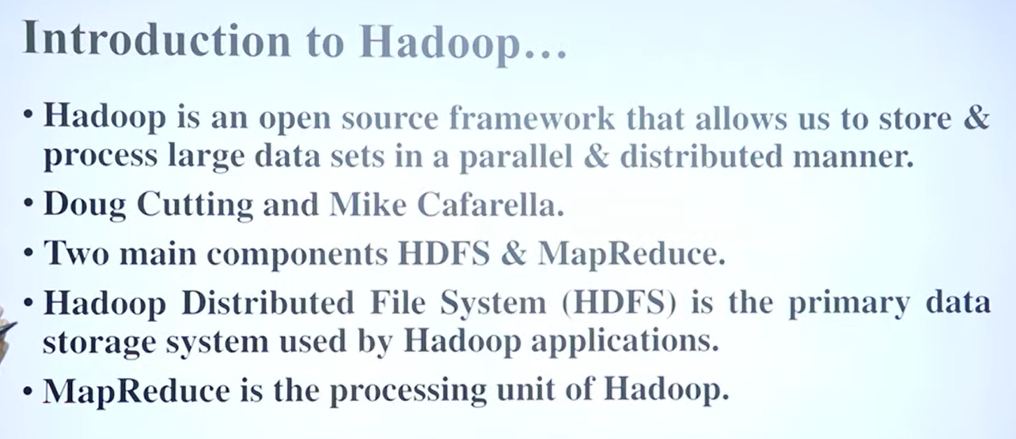**Origin of Hadoop and Big Data (0:07-2:30)**: The story of Hadoop begins in the early 21st century (around 2001) with the rise of the internet. Before the internet, data was typically structured and limited in volume, allowing for storage on single devices and processing by single elements. However, with the internet's popularity, the type of data rapidly changed to include text, images, and videos, leading to an explosion in data volume, commonly referred to as **Big Data**.
* **Development of Hadoop (2:31-3:17)**: Around 2002, **Doug Cutting** (often called the Father of Big Data or Father of Hadoop) and Mike started working on a project named Hadoop. Their goal was to find a way to easily store and process this massive amount of Big Data. In 2008, Yahoo declared Hadoop an open-source project, and by 2012, Apache made it publicly available, leading to its popularity as **Apache Hadoop**.
* **What is Hadoop? (3:18-4:20)**: Hadoop is an **open-source framework**, not just a software or a simple database. It's a complete framework designed to properly store and access data in a **distributed manner**. This means instead of storing all data in a single location, Hadoop distributes it across different areas or clusters, allowing for parallel access. Initially written in Java, it supports programming in C++, Python, and Java.
* **Core Components of Hadoop (4:23-9:11)**: The two most fundamental components of the Hadoop framework are:
  + **HDFS (Hadoop Distributed File System)** (4:33-8:18): Similar to file systems in Windows or Linux, HDFS is specifically designed for Big Data. It avoids storing large files in a single location. Instead, it **divides** a file (e.g., a 1280 MB file) into smaller blocks, typically 128 MB by default, and stores these partitions in different locations called **Data Nodes**. This distributed storage uses existing, cost-effective commodity hardware. A **Master Node** stores metadata (6:31), which provides information about where each data block is located, its size, and other characteristics. To prevent data loss in case of a node failure, HDFS uses **replication (or duplication)** (7:19-8:18), creating multiple copies (typically 2-3) of each data block on different data nodes.
  + **MapReduce** (8:27-9:11): This is the **processing element** of Hadoop, acting like its CPU. Its main function is to process user queries by accessing data in parallel. MapReduce works on a **key-value pair** concept, reducing large problems into smaller ones and operating like a "divide and conquer" strategy to convert queries into answers.

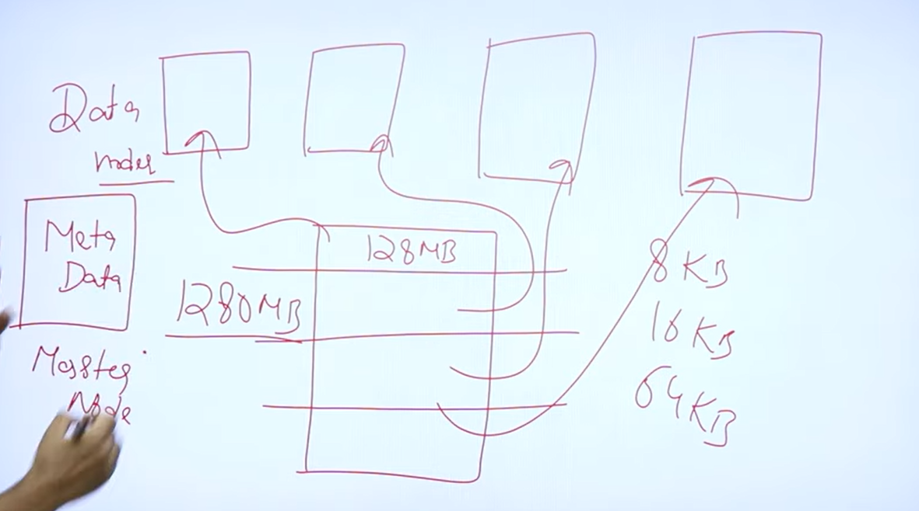

**Introduction to Hadoop**

The video covers:

* **What is Hadoop:** Hadoop is an open-source framework designed for processing and storing big data. It's free to use and was developed by Doug Cutting and Mike Cafarella (0:00-0:18). It was named after Doug Cutting's son's toy elephant (0:45-0:50).
* **Hadoop Distributed File System (HDFS):** HDFS is designed to store and manage large amounts of data efficiently. It addresses the challenges of storing massive datasets on a single system by distributing data across multiple machines (1:25-2:45).
* **MapReduce:** MapReduce is a programming model used within Hadoop for processing large datasets in parallel. It breaks down large data processing tasks into smaller sub-tasks that can be executed concurrently across different systems (2:50-3:27).
* **Why Use Hadoop:** Hadoop is essential because traditional database systems struggle to handle the immense volume and velocity of modern big data. It overcomes the limitations of older systems by providing a robust and scalable solution for storing and processing continuously generated data (3:40-4:27) 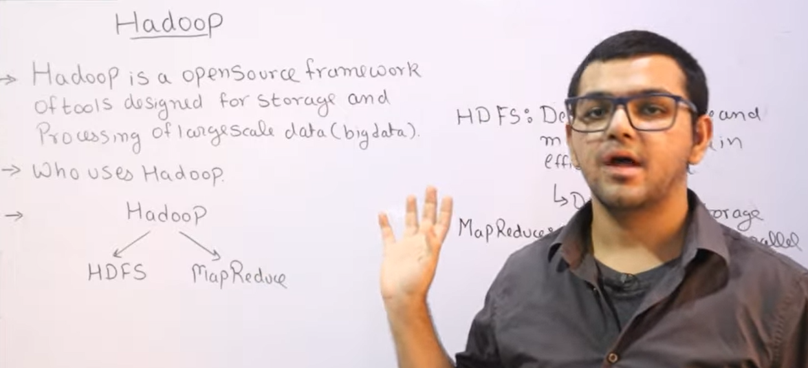

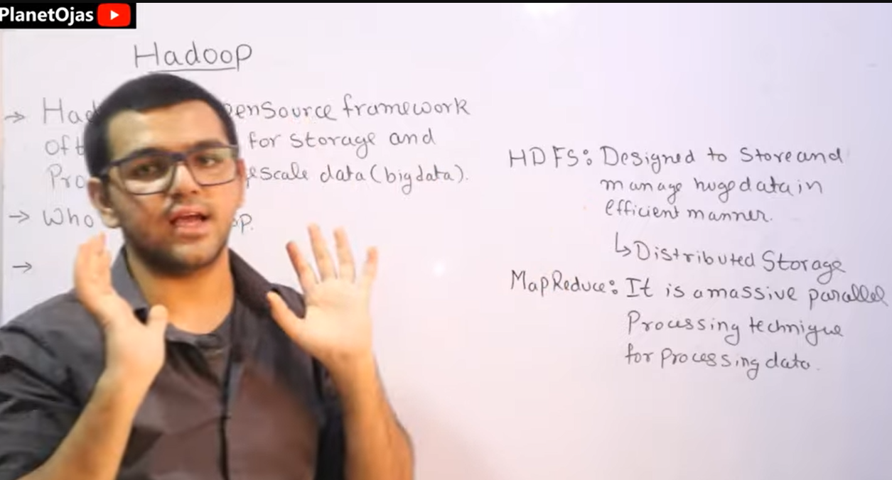

**Hadoop ll Introduction to Hadoop ll Features Explained with Examples**

# What Is Hadoop? | Introduction To Hadoop | Hadoop Explained |Simplilearn

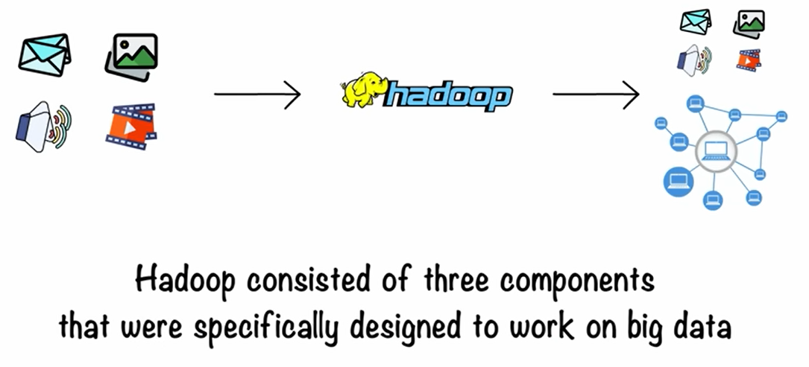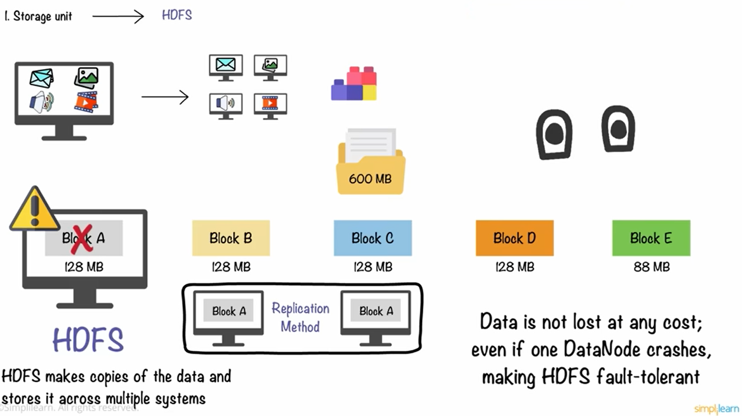

# Hadoop🐘Ecosystem | All Components Hdfs🐘,Mapreduce,Hive🐝,Flume,Sqoop,Yarn,Hbase,Zookeeper🪧,Pig🐷

The video explains the various components of the **Hadoop ecosystem** (0:04) and how they work together to manage, process, and analyze large datasets in a distributed environment.

Here's a summary of the key components and their roles:

* **HDFS (Hadoop Distributed File System)** (0:47): This is a mandatory component responsible for storing and managing data in a distributed manner, allowing for easy access and processing. It acts as the file system for Hadoop, similar to NTFS in Windows or NFS in Linux (1:00-1:18).
* **YARN (Yet Another Resource Negotiator)** (1:26): YARN manages resources and schedules jobs within the Hadoop cluster. Initially, resource management was part of MapReduce, but due to increasing data and slowing performance, YARN was separated to handle resource allocation and job scheduling efficiently (1:55-2:40).
* **MapReduce** (1:37): This component is used for processing data in a distributed and parallel fashion. It processes data stored in HDFS and converts it into output (1:41-1:50).
* **Flume and Sqoop** (3:16): These tools are used for data ingestion or collection.
  + **Sqoop** (3:52): Used for structured data, specifically for importing and exporting data between Hadoop and relational databases like MySQL, SQL Server, or Oracle (3:52-4:18).
  + **Flume** (3:56): Used for unstructured or semi-structured data, especially for collecting streaming data, live streams, photos, videos, and log files in real-time (4:24-4:43).
* **HBase** (4:46): A NoSQL, column-oriented database that allows for storing large amounts of data without predefined schemas, unlike traditional relational databases (5:05-5:21).
* **Hive** (6:04): Used for SQL-like querying of structured data within Hadoop, allowing users familiar with SQL to interact with Hadoop data without extensive Java coding (6:04-6:33).
* **Pig** (6:35): A scripting platform that simplifies complex MapReduce programming. It significantly reduces the lines of code required for data processing tasks, making development faster (6:40-7:02).
* **Mahout** (7:05): A machine learning library that provides various algorithms for building machine learning applications on top of Hadoop (7:07-7:42).
* **Cloudera** (9:16): A platform that provides a user-friendly interface for managing, monitoring, and exploring data within the Hadoop ecosystem (9:16-9:24).
* **Oozie** (9:31): A workflow scheduler that helps in automating and orchestrating jobs within the Hadoop system, scheduling tasks, and managing their execution times (9:34-9:53).
* **ZooKeeper** (9:54): Provides centralized coordination services for large Hadoop clusters, managing and monitoring different components across a very large scale, essentially acting as a "zoo keeper" for all the components (9:56-10:55).

The video emphasizes that the Hadoop ecosystem facilitates **data ingestion** (7:50), **data storage** (8:02), **data processing** (8:22), and **data analysis/visualization** (8:41) to enable users to interact with and derive insights from massive datasets (8:54).

# What is HDFS | Name Node vs Data Node | Replication factor | Rack Awareness | Hadoop🐘🐘Framework

Hadoop Distributed File System (HDFS) is a core component of Apache Hadoop, designed for storing and managing large datasets for big data analytics (0:30-1:13). It addresses the challenge of storing massive amounts of data efficiently, while MapReduce handles the processing (1:03-1:10). HDFS is a robust, distributed file system built upon traditional hierarchical file system architecture, but scaled for huge datasets (1:13-1:48).

Key components and concepts of HDFS include:

* **NameNode:** This acts as the "boss" or "master node," responsible for managing the file system namespace and storing metadata (e.g., file names, permissions, block locations, replication factors) (2:09-2:21, 5:07-5:56).
* **DataNodes:** These are the "employees" that store the actual data in physical blocks (2:24-2:47). HDFS works with commodity hardware (3:00-3:07).
* **Data Storage and Block Size:** HDFS divides large files into smaller blocks, with a default size of 128 MB (3:19-4:11). These blocks are distributed across various DataNodes for parallel access and processing (4:39-5:07).
* **Replication Factor:** To ensure fault tolerance and high availability, HDFS replicates each data block multiple times, with a default replication factor of three (5:58-6:46). This means if one DataNode goes down, the data can still be accessed from its replicas (6:49-7:23).
* **Rack Awareness:** HDFS intelligently places replicas across different racks to mitigate data loss if an entire rack fails (7:26-8:33). It also prioritizes placing one copy locally to enable faster access for read operations (8:35-9:50).
* **NameNode Functions:** The NameNode maintains an **FSImage**, which is a snapshot of the file system's metadata, and an **EditLog**, which records all changes made to the file system (9:53-10:33). A **Secondary NameNode** assists by periodically merging the EditLog into the FSImage to keep it updated, acting as a helper to the NameNode (10:43-11:52).
* **Heartbeat Messages:** DataNodes regularly send "heartbeat" messages to the NameNode (every 3 seconds) to indicate they are alive and functioning (11:54-12:17).
* **Read and Write Operations:** When reading data, the client interacts with the NameNode to get the block locations, then directly accesses the DataNodes (12:34-13:01). Write operations are more expensive as changes need to be synchronized across all replicas simultaneously (13:03-13:38

# What is MapReduce♻️in Hadoop🐘| Apache Hadoop🐘

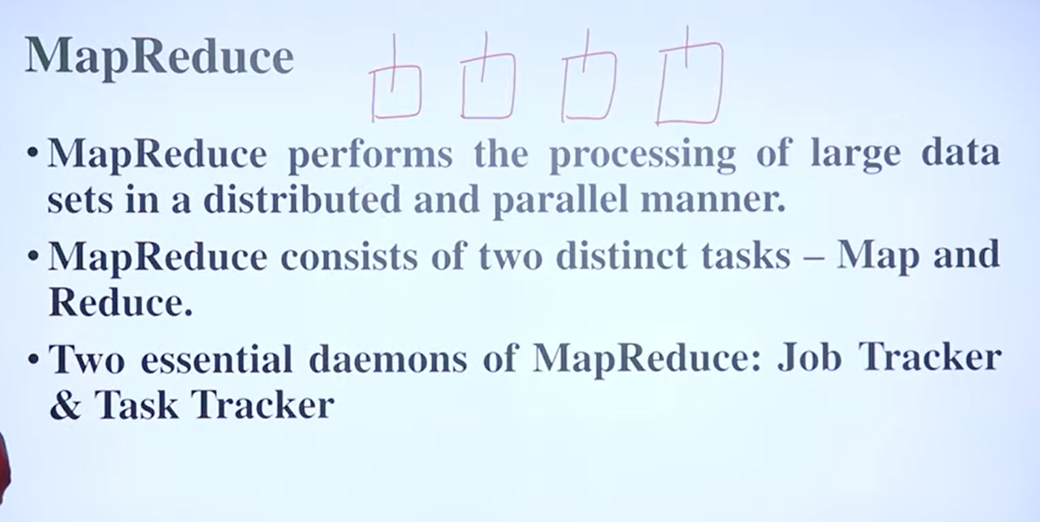Key concepts discussed include:

* **Purpose of MapReduce:** It acts as the processing unit for big data stored in HDFS (Hadoop Distributed File System), enabling parallel processing to improve efficiency and reduce processing time (1:00-1:19).
* **Map and Reduce Tasks:** MapReduce operates on a "divide and conquer" approach, splitting large problems into smaller ones.
  + **Map Task (Mapper Class):** Breaks down the large input into smaller pieces, often converting data into key-value pairs (1:41-2:26).
  + **Reduce Task (Reducer Class):** Combines the intermediate results generated by the Map tasks to produce a final output (2:51-2:58).
* **MapReduce Daemons:** Two main background processes manage the MapReduce operations.
  + **Job Tracker:** Acts as the master node or "boss," responsible for scheduling processes, providing resources, and monitoring the overall job execution (3:11-3:46).
  + **Task Tracker:** The "employee" node that performs the actual work, executing tasks on the data nodes where the data is stored (3:32-3:48).
* **Data Locality:** A crucial concept in MapReduce is that processing happens where the data resides (on local disks of data nodes), rather than moving data to the processing unit. This minimizes network delay and improves efficiency (5:00-6:52).
* **Word Count Example:** The video illustrates the MapReduce workflow with a word count example (6:57).
  + **Splitting:** The input paragraph is divided into smaller chunks and distributed across data nodes (7:26-7:46).
  + **Mapping:** Each chunk is processed in parallel to generate key-value pairs (word, count) (7:49-8:26).
  + **Shuffling/Grouping:** Similar keys (words) from different mappers are grouped together (8:30-9:14).
  + **Reducing:** The grouped key-value pairs are processed to get the final count for each word (9:16-9:27).
  + **Final Output:** The combined results provide the total count for each word (9:33-9:43).

# 

# What Is Hadoop? | Introduction To Hadoop

**Hadoop** as a solution for managing and processing **Big Data**.

The video begins by illustrating the challenges of traditional data processing systems with an analogy of a farm (0:26) and then moves on to explain the rise of **Big Data** (2:30), defining it by its **five V's**: **Volume**, **Velocity**, **Variety**, **Value**, and **Veracity** (6:31). It highlights the challenges of processing large volumes of diverse data with single storage and serial processing methods (9:40).

**Hadoop** is presented as a framework designed to manage big data storage in a distributed way and process it in parallel (11:17). The core components of Hadoop include:

* **Hadoop Distributed File System (HDFS)** (12:20): This is Hadoop's storage unit, designed for storing huge datasets on commodity hardware. It uses a **NameNode** (master) to manage metadata and **DataNodes** (slaves) to store the actual data and perform replication (13:17). Data is distributed and replicated (default three times) across these nodes, ensuring fault tolerance and data security (16:05).
* **Hadoop MapReduce** (17:10): This is the processing unit of Hadoop, a programming technique for parallel processing of huge data stored in HDFS. It involves a **Map phase** where data chunks are processed independently, followed by a **Shuffle and Sort phase** to group data, and finally a **Reduce phase** where aggregated results are obtained (19:22).
* **Hadoop YARN** (Yet Another Resource Negotiator) (22:55): This acts as the resource management unit or "operating system" for Hadoop. It's responsible for managing cluster resources and job scheduling across the different nodes (23:30).

A practical **use case of Hadoop** is demonstrated through a scenario of combating fraudulent activities in banking (25:16). Hadoop enabled a bank to store massive amounts of structured and unstructured data, process server logs, customer data, and transactions efficiently, leading to in-depth analysis and improved detection of fraudulent activities like malware and phishing attempts (27:23).

The video concludes by reiterating these key takeaways regarding Big Data, Hadoop's components (HDFS, MapReduce, YARN), and its real-world application in fraud detection (28:50).

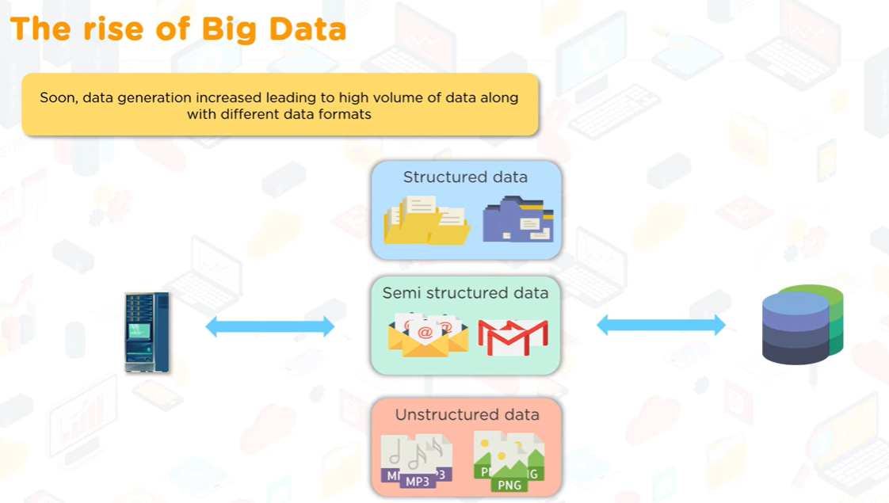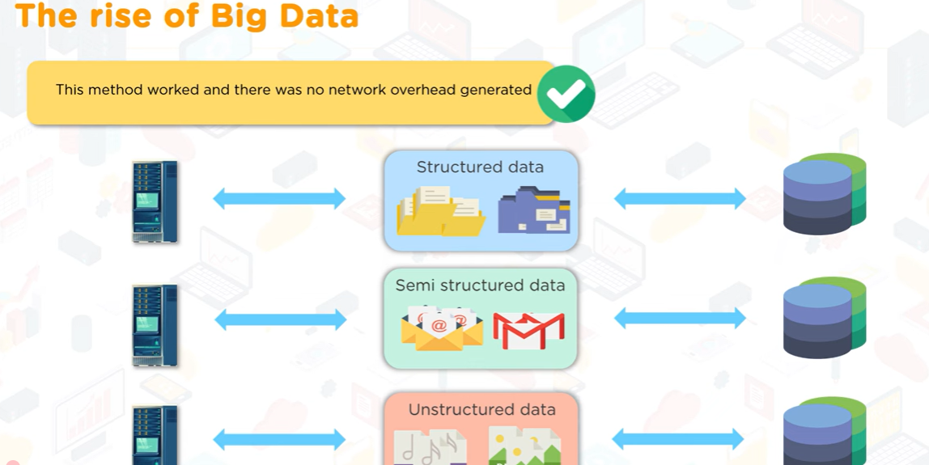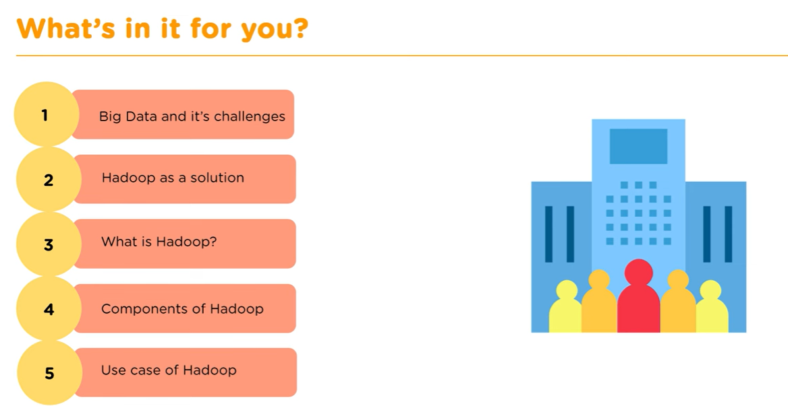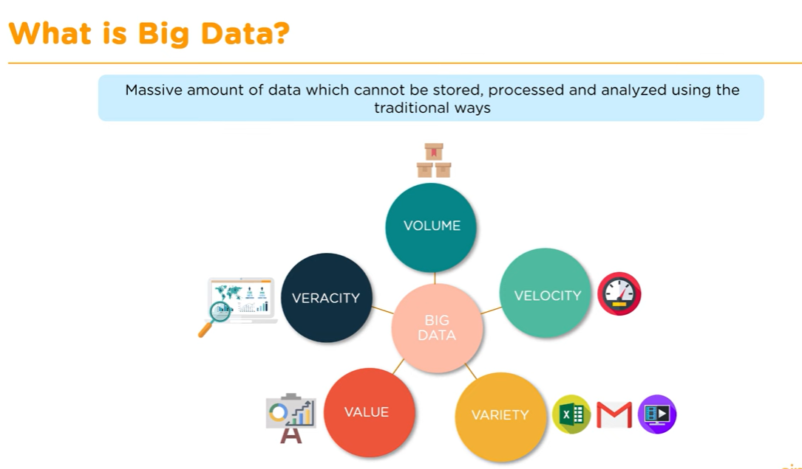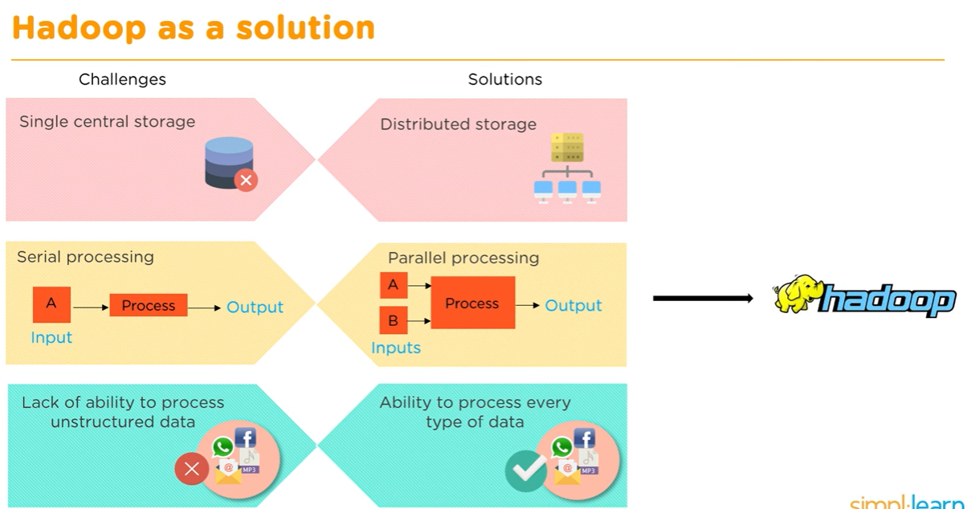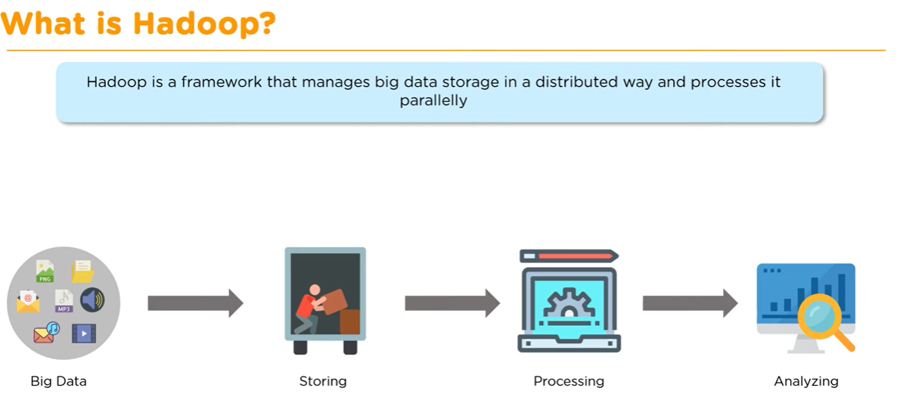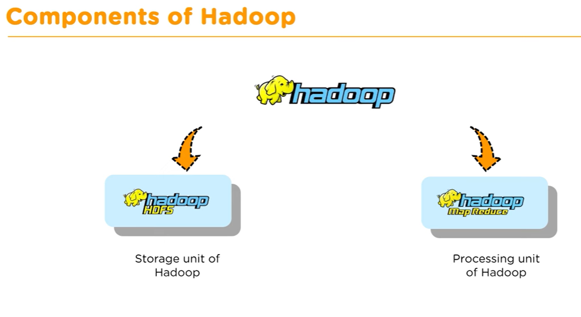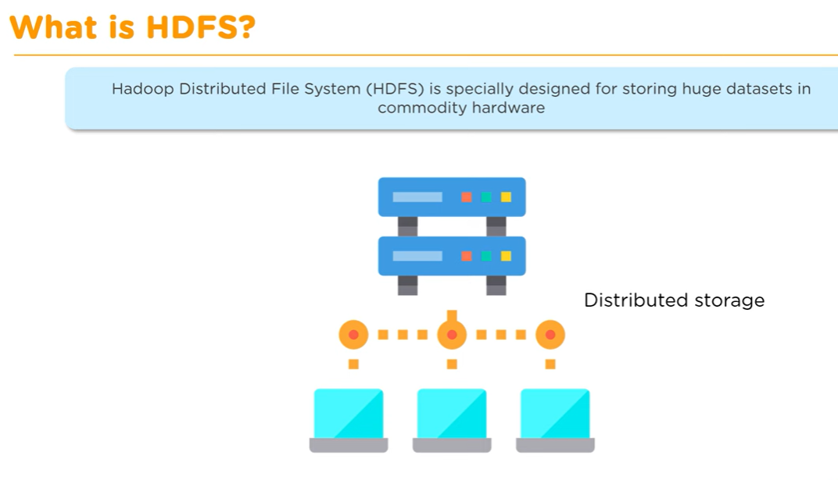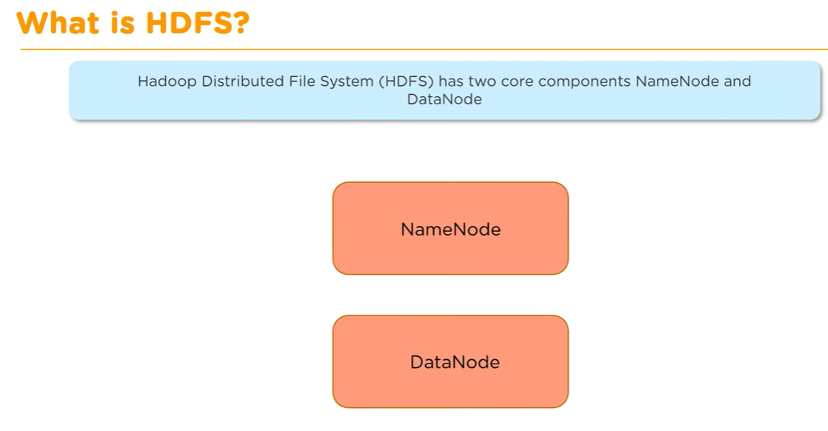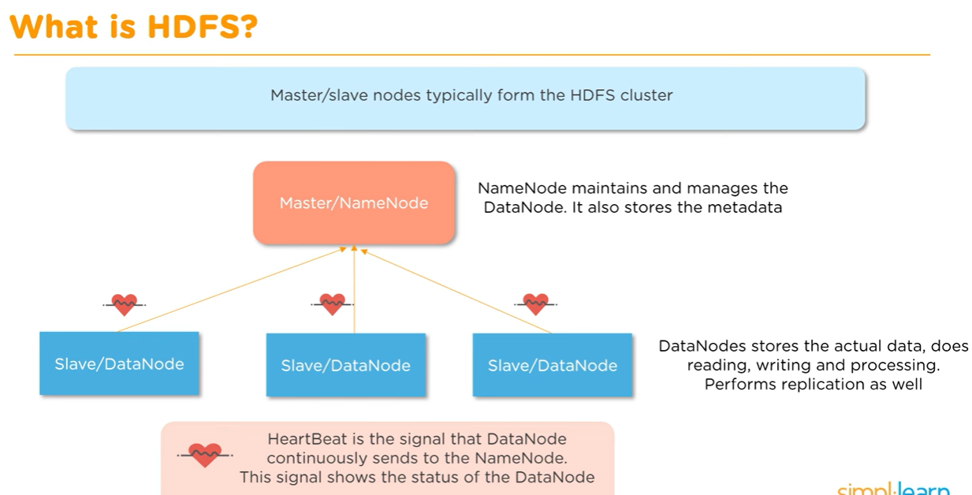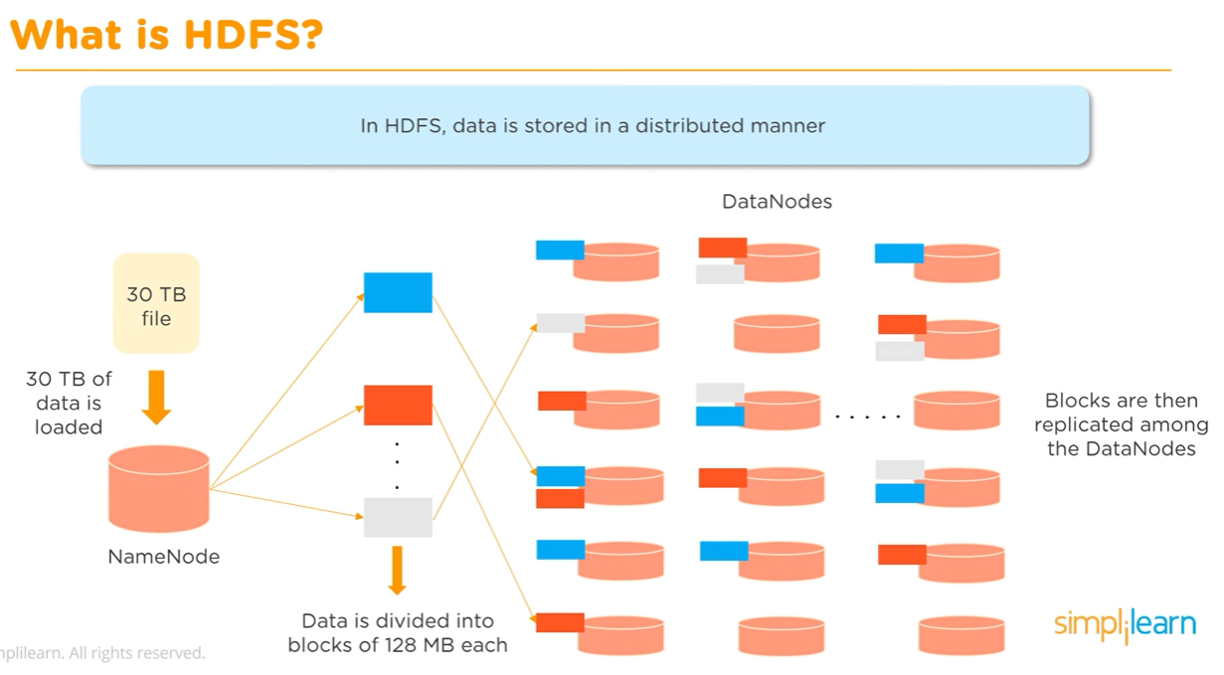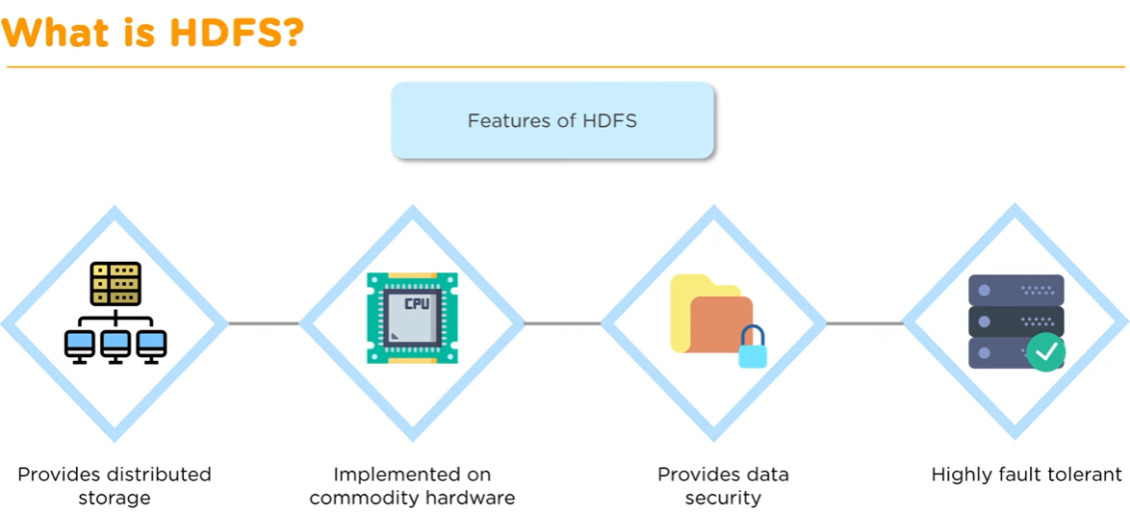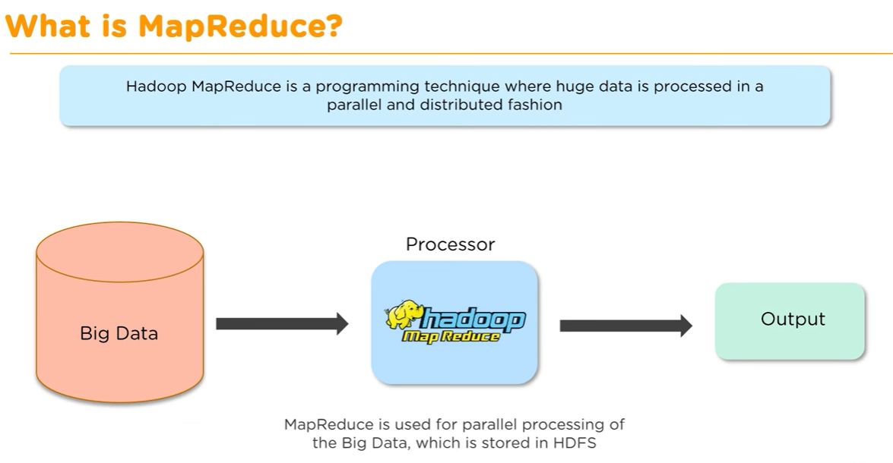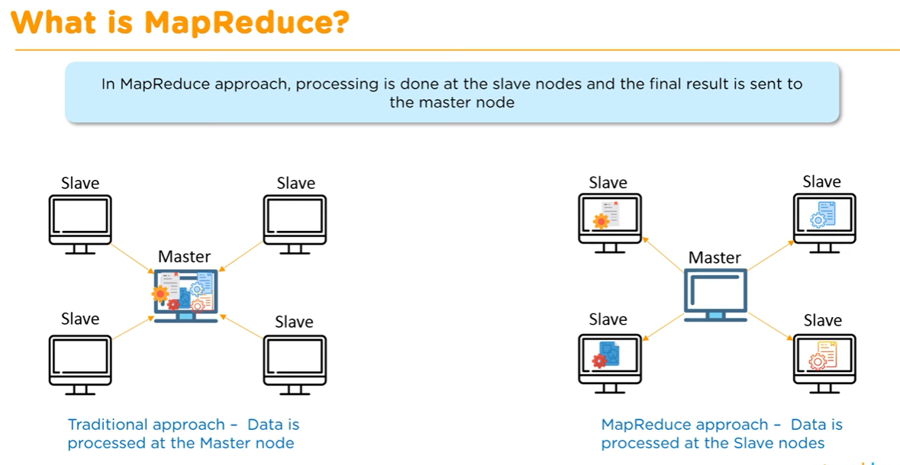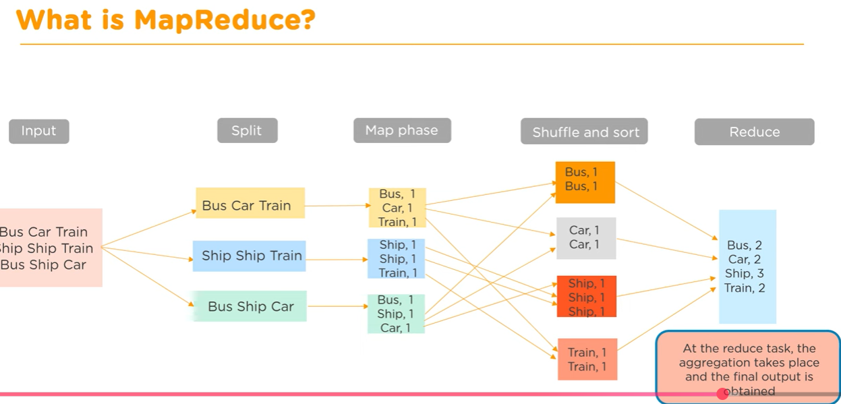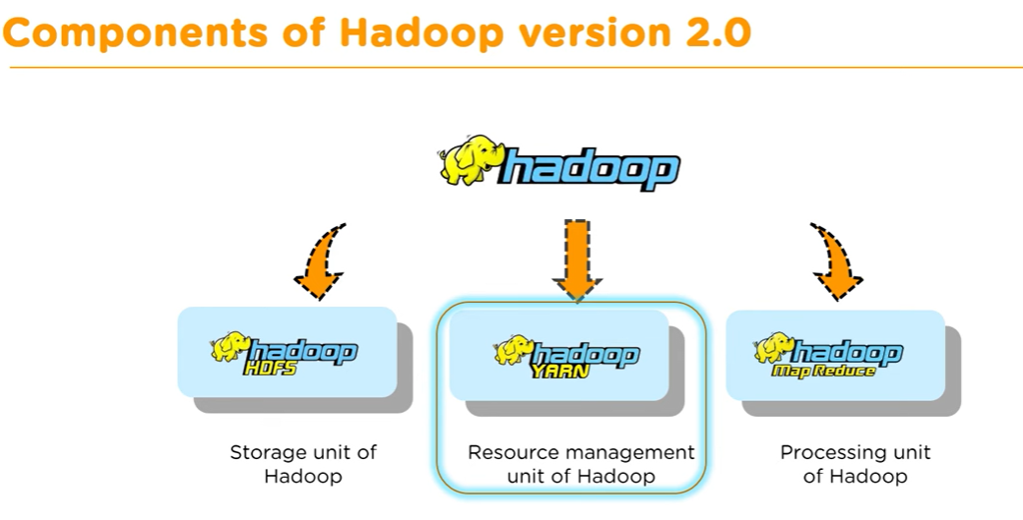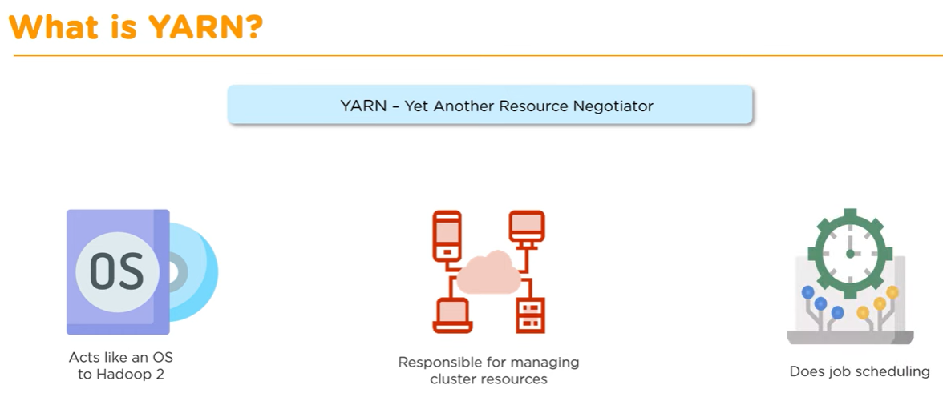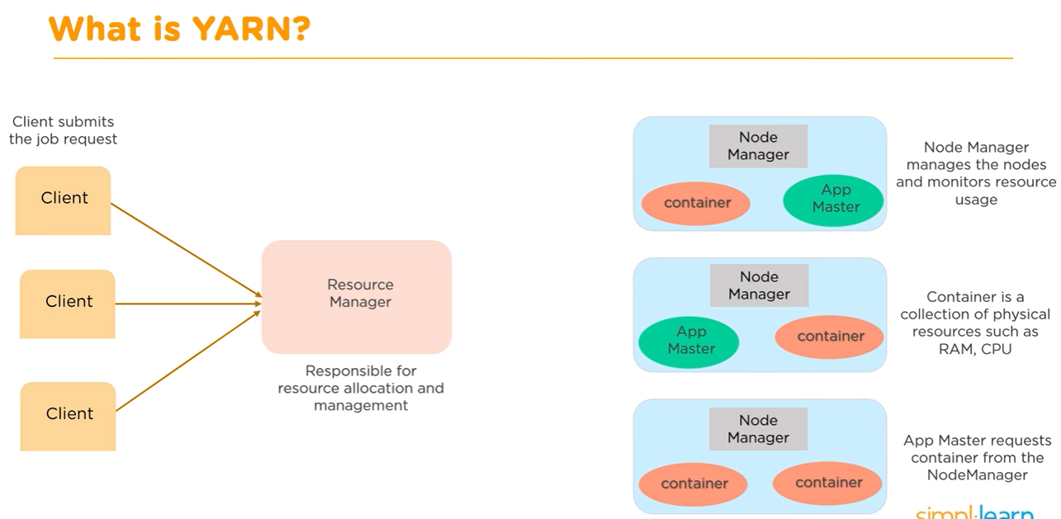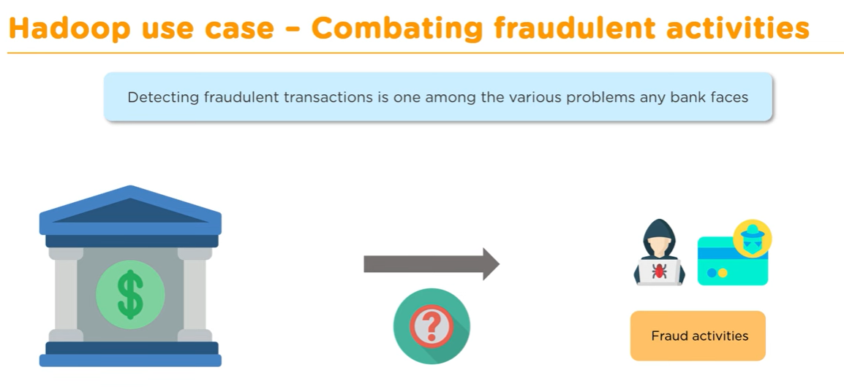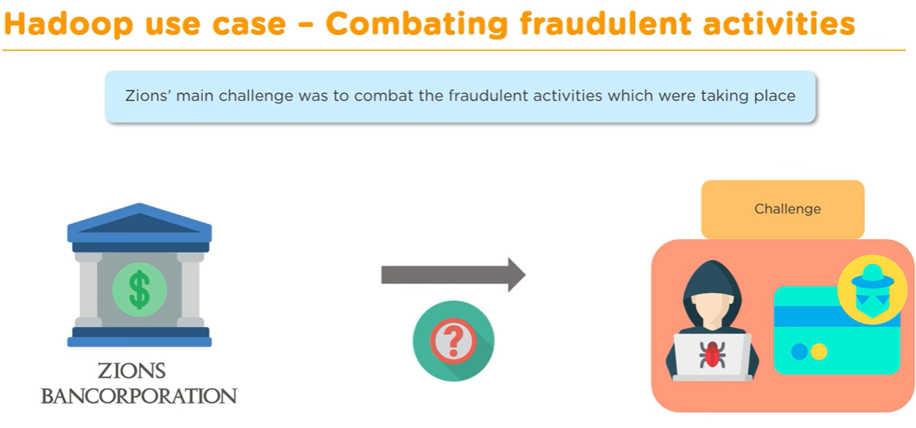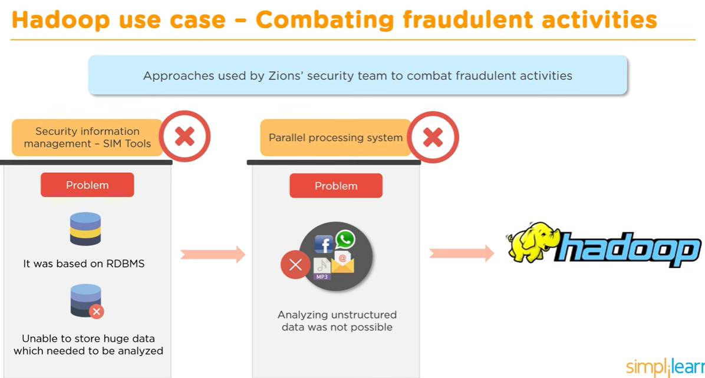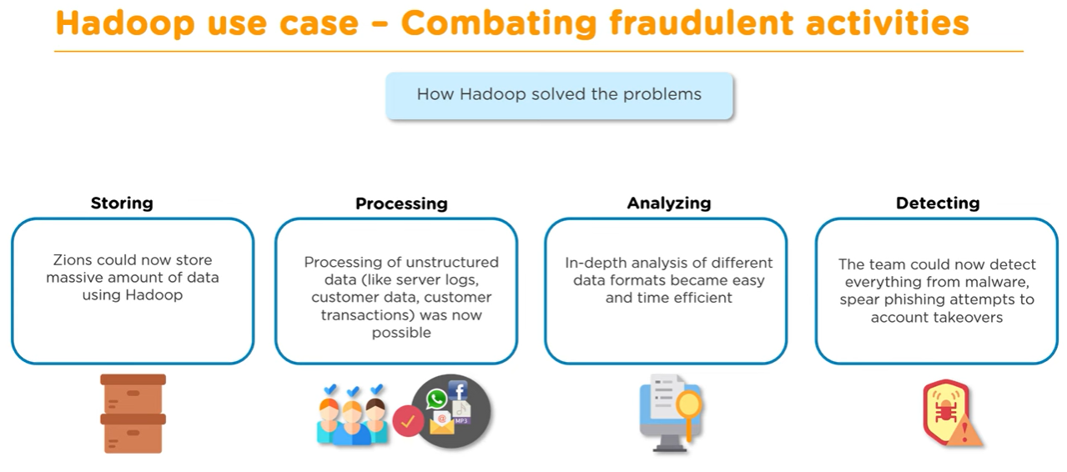

**Hadoop Ecosystem**

the **Hadoop Ecosystem** within the context of Big Data Analytics (0:00). The speaker explains that Hadoop is a platform designed to solve big data problems, often requiring various tools due to its complexity (0:13-0:28).

Key components and tools discussed include:

* **MapReduce & HDFS (Hadoop Distributed File System)** (0:30): These are fundamental components of the Hadoop architecture. HDFS is responsible for storing data (3:08-3:13) while MapReduce handles processing (3:04-3:08) and acts as the job tracker (2:45-2:50). The video illustrates their interaction with an example of finding the YouTube channel with the most videos (1:40-2:42).
* **Apache Flume** (3:40): Used to import streaming data into HDFS (3:45-3:53).
* **Apache Hive** (4:30): Provides a data warehousing solution on top of HDFS, allowing SQL-like queries for easy data retrieval and analysis (4:39-4:54).
* **HBase** (5:00): A NoSQL database that offers random, real-time read/write access to big data stored in HDFS, addressing the limitations of HDFS for quick data access (5:51-6:02).
* **Mahout** (6:00): A machine learning library built on Hadoop, enabling the creation of scalable machine learning algorithms (6:18-6:25).
* **Pig** (7:10): A high-level platform for analyzing large datasets. It simplifies the process of writing complex MapReduce jobs with its Pig Latin language (7:10-7:55).
* **Sqoop** (8:20): Facilitates data transfer between Hadoop and relational database management systems (RDBMS), allowing import and export of structured data (8:32-8:40).
* **ZooKeeper** (8:40): Manages and coordinates the various services within the Hadoop ecosystem, ensuring smooth communication and operation among them (9:10-9:23).

# Hadoop Architecture ll Map Reduce,HDFS,YARN Framework, Common Utilities

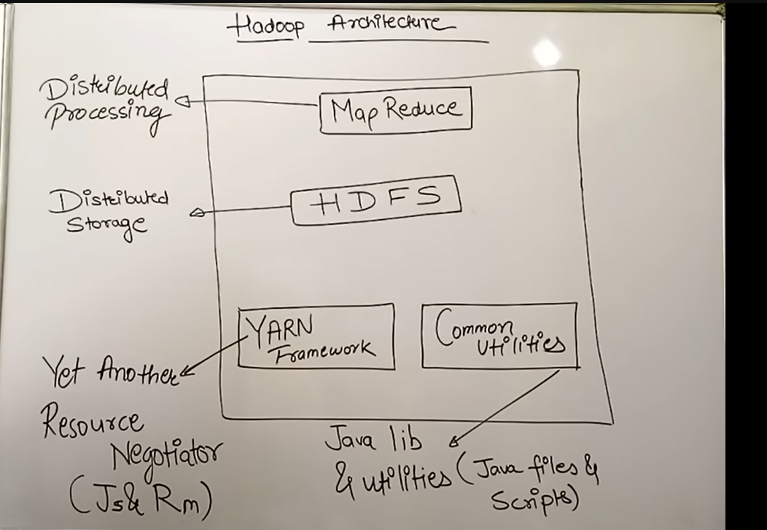

**Big Data Analytics Lectures | Introduction to Hadoop**

Here's a breakdown of the key topics:

* **Introduction to Hadoop** (0:02-0:58): The speaker introduces Hadoop as a compulsory subject for Big Data Analytics in Mumbai University, noting its syllabus matches that of Data Science. The video will specifically cover Hadoop's architecture.
* **What is Hadoop?** (1:25-3:06): Hadoop is defined as an **open-source software framework** that provides **huge data storage**. It's described as a cloud-like platform where data can be stored, emphasizing that it's a framework, not just a software, similar to how Google Cloud is a platform.
* **Basic Diagram of Hadoop** (3:06-3:56): The video presents a basic diagram showing clients accessing a **cluster** of networked machines. A cluster is explained as a group of machines networked together to process client requests, rather than a single machine.
* **Components of Hadoop** (3:58-5:02): Hadoop consists of five main components, referred to as "demons" because they are essential resident programs for Hadoop to function. These are:
  1. Name Node
  2. Job Tracker
  3. Secondary Name Node
  4. Data Node
  5. Task Tracker
* **Physical Architecture and Working of Hadoop** (5:03-9:47): The video explains the working of these components in the physical architecture.
  1. **Client Job Submission**: A client submits a job to the **Name Node** (6:26).
  2. **Job Division**: The Name Node passes the job to the **Job Tracker** (6:54). The Job Tracker then divides the job into smaller tasks (7:06).
  3. **Task Distribution**: These tasks are distributed to **Data Nodes** (7:14), which act as managers within the system.
  4. **Task Execution**: Each Data Node assigns its tasks to **Task Trackers** (7:56), which are responsible for executing the actual work (8:02).
  5. **Task Completion and Reporting**: Once Task Trackers complete their assigned tasks, they report back to the Job Tracker (8:17). The Job Tracker then accumulates the results and sends the final output back to the client (8:43).
  6. **Secondary Name Node**: This component acts as a monitor, continuously observing the processes and reactivity of the system (9:00).
  7. **Communication and Failure Handling**: The Job Tracker continuously communicates with Task Trackers to monitor their status (9:26). If a Task Tracker fails to respond, the Job Tracker assumes it has failed and reassigns its tasks to another Task Tracker (9:32).

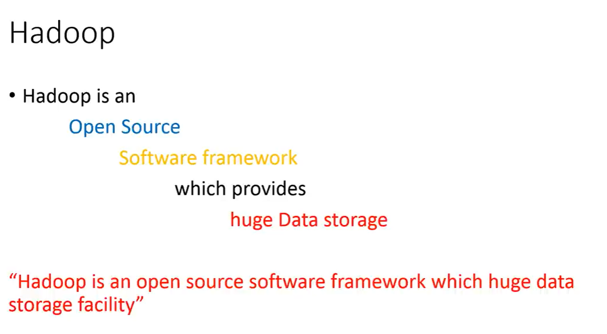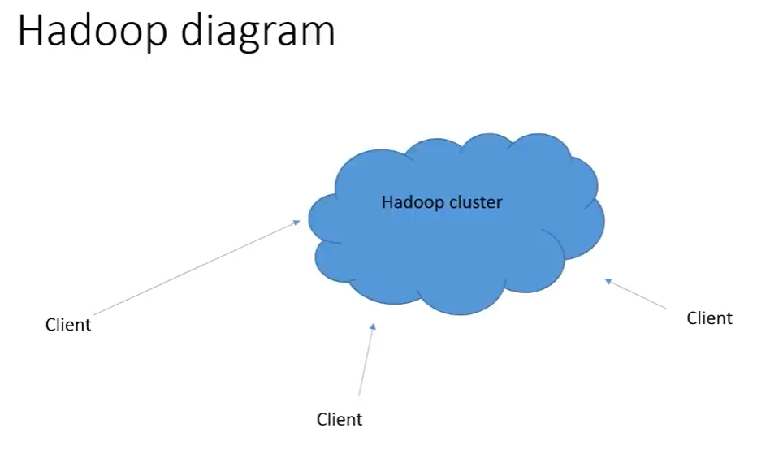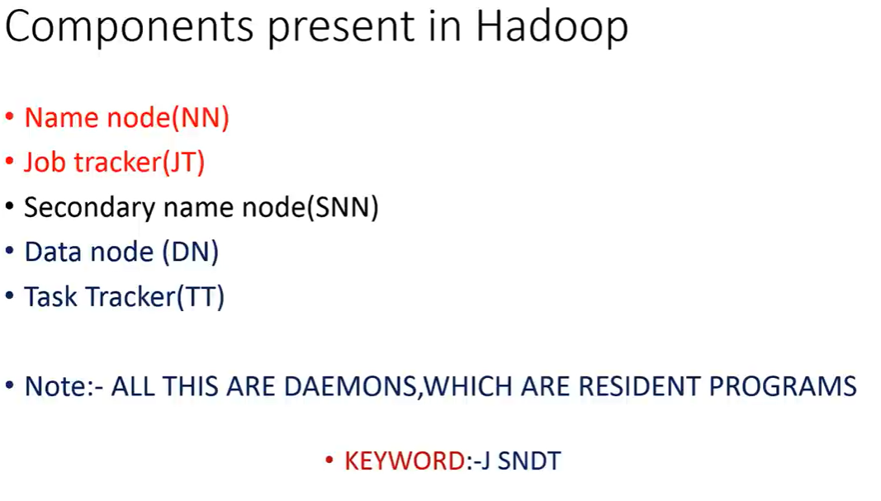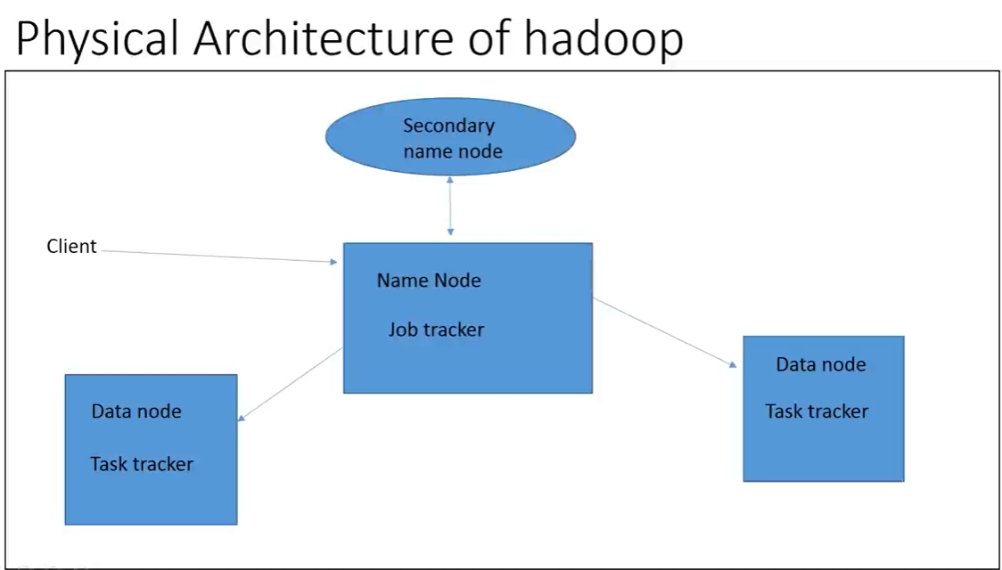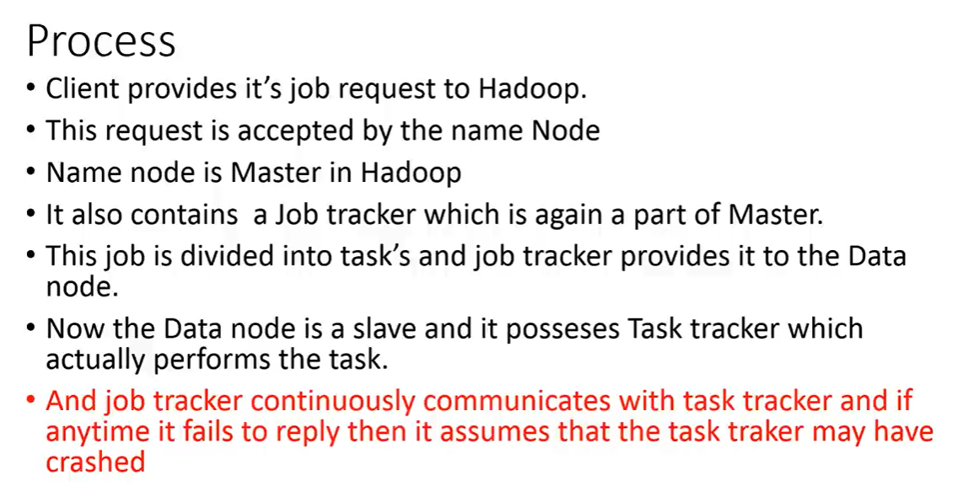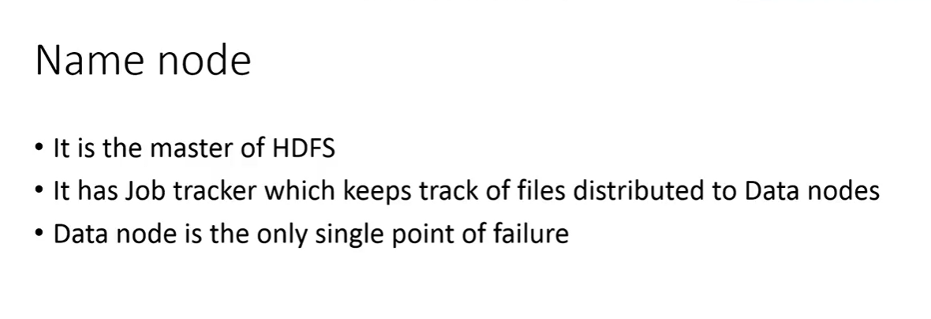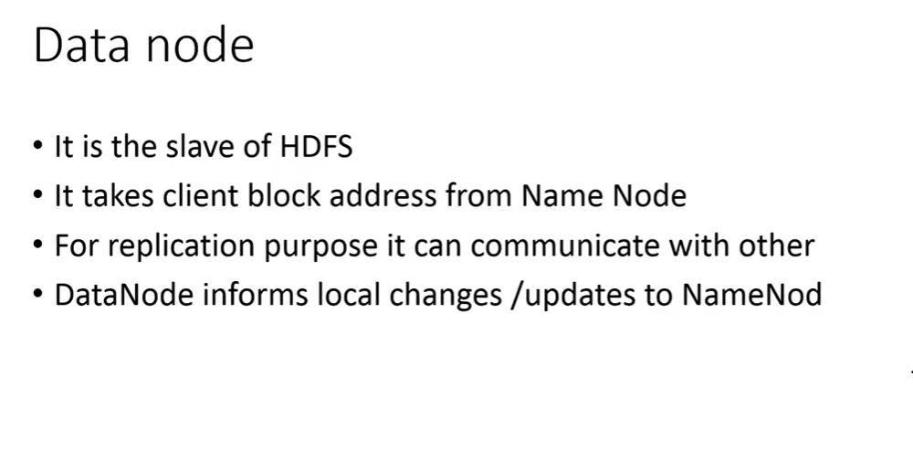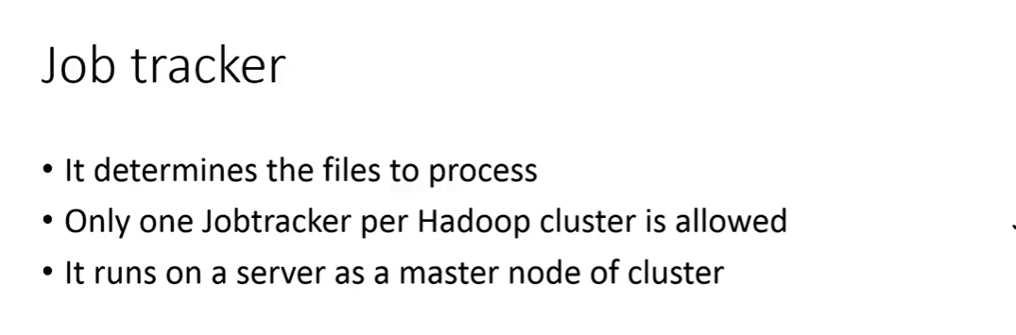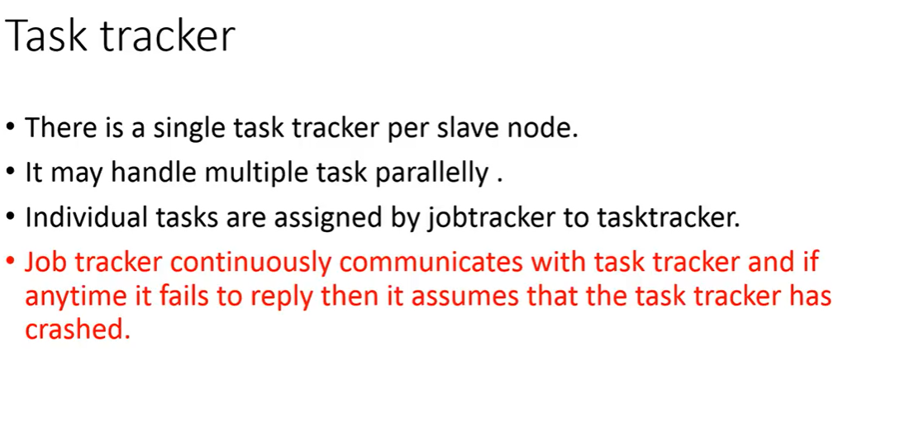

**Big Data Analytics Lectures | Euclidean Distance with Solved Example**

# Introduction to BIG Data

# Dijkstra's Algorithm - Single Source Shortest Path - Greedy Method

Here's a breakdown of the video's content:

* **Introduction and Advantages** (0:39): Dijkstra's Algorithm is a **greedy approach** that finds the shortest path from a single source in a graph. It's often referred to as a **single-source shortest path algorithm** or a **minimization algorithm** because it aims to minimize the path cost. Real-world applications include **Google Maps** (0:45), **social networking**, **DNA mapping**, and **telecommunication networks** (1:13). The algorithm always provides an **optimal answer** (1:55).
* **Working Principle - Relaxation** (1:57): The core of Dijkstra's Algorithm lies in its **relaxation technique**. The video explains this concept using a small graph with three vertices (1, 2, 3). Initially, the distance to all nodes from the source (e.g., node 1) is considered infinite, except for the source itself (0:00). The algorithm iteratively updates the shortest distance to each node. For example, to find the shortest path from node 1 to node 2, it compares the current distance to node 2 with the sum of the distance to the current node (node 1, which is 0) and the cost of the edge from node 1 to node 2 (20). If the new path is shorter, the distance is updated (3:24). This process is repeated for all adjacent nodes (5:25).
* **Detailed Example** (7:48): The video then demonstrates Dijkstra's Algorithm on a larger, **undirected graph** with six vertices. It shows how to create a table to track the shortest distances from the source node (node 1) to all other nodes (2, 3, 4, 5, 6). The steps involve:
  1. Initializing distances: Source to itself is 0; others are infinite (8:24).
  2. Updating direct connections: For example, from node 1, direct paths to node 2 (cost 7), node 3 (cost 9), and node 6 (cost 14) are updated (9:06).
  3. Selecting the minimum: The node with the minimum current shortest distance (e.g., node 2 with cost 7) is selected and fixed (9:47).
  4. Relaxing neighbors: From the fixed node (node 2), its neighbors are checked. If a shorter path is found through node 2, the distances are updated (10:19).
  5. Repeating the process: Steps 3 and 4 are repeated until all nodes have been visited and their shortest distances from the source are finalized (11:08-14:33). The final result is a tree-like structure showing the shortest paths from the source to all other nodes (14:47).

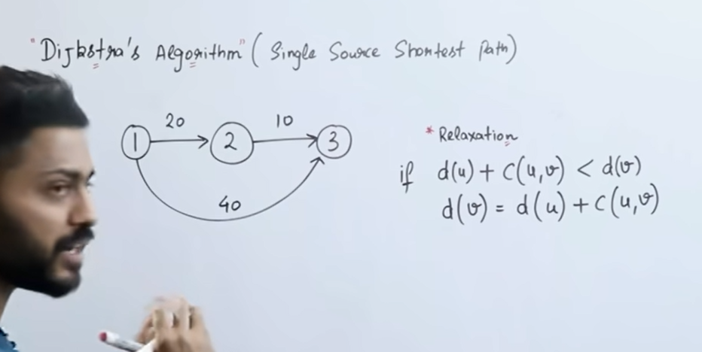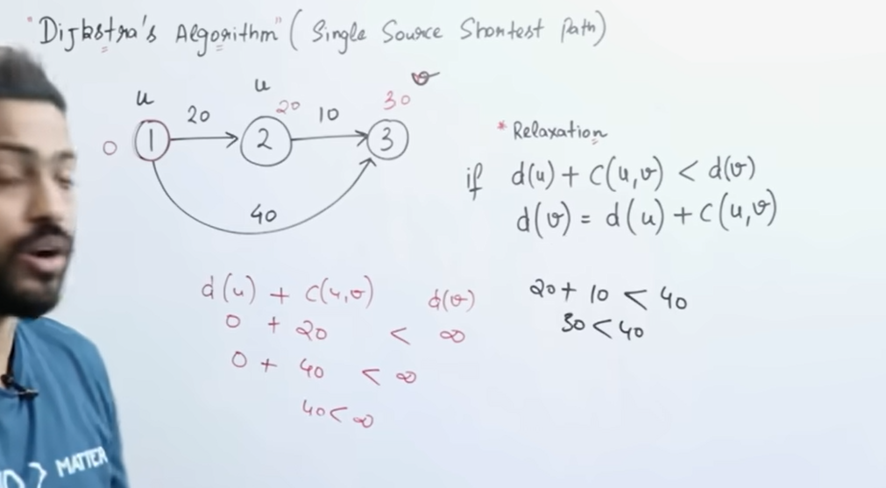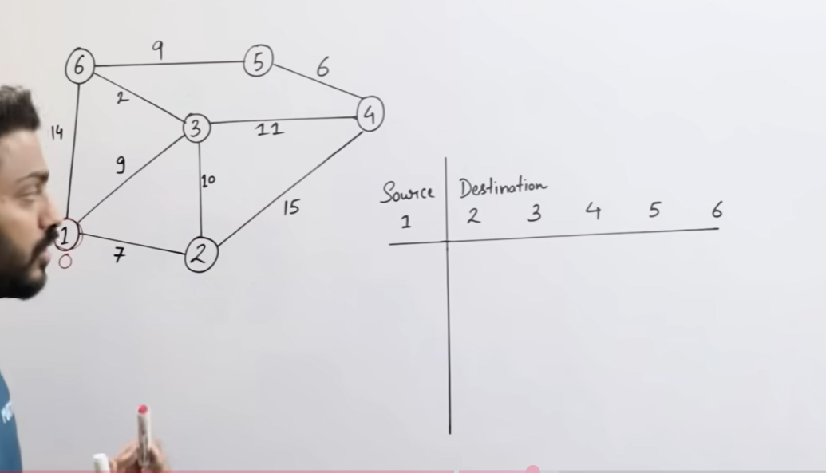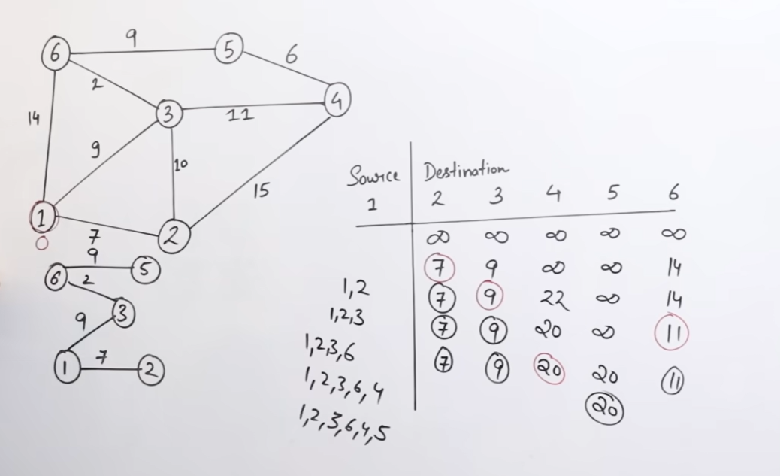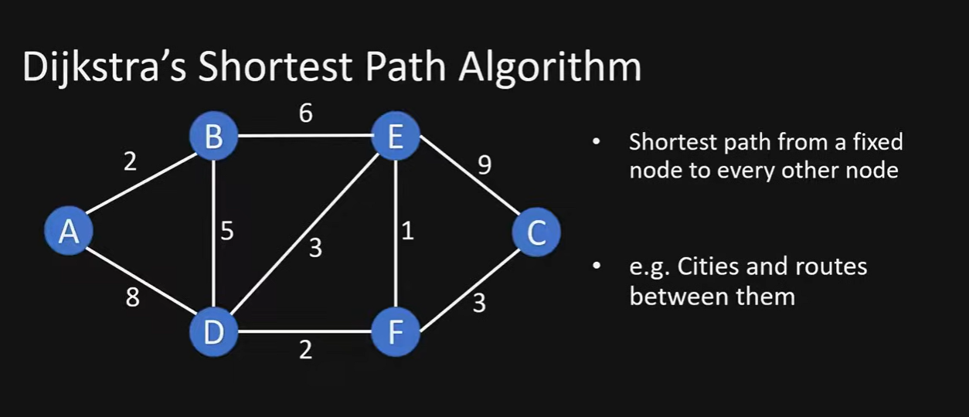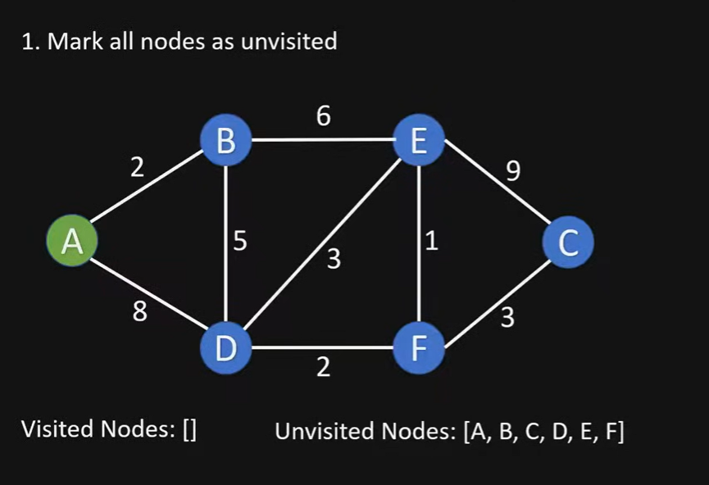The video details the following steps to implement Dijkstra's algorithm:

1. **Initialization:** All nodes are initially marked as unvisited. Two lists are created: unvisited nodes (containing all graph nodes) and visited nodes (initially empty) (0:45-1:01).
2. **Tentative Distance Assignment:** Each node is assigned a tentative distance value. The starting node's distance is set to 0, and all other nodes are set to infinity (1:02-1:32). A table is used to track the current shortest distance from the start node to each node and the previous node that leads to this shortest distance (1:32-1:43).
3. **Iteration and Update:** The algorithm iteratively selects the unvisited node with the smallest tentative distance (2:49-3:11). For the current node, it calculates the distances to all its unvisited neighbors by adding the current node's distance to the weight of the edge connecting them (3:18-3:37). If a newly calculated distance is shorter than the current tentative distance for a neighbor, the table is updated with the new shorter distance and the current node as the previous node (2:05-2:22, 3:56-4:02, 4:13-4:27).
4. **Marking Visited:** Once all unvisited neighbors of the current node have been processed, the current node is marked as visited and moved from the unvisited nodes list to the visited nodes list (2:33-2:40, 4:32-4:37, 5:38-5:41, 7:02-7:05, 7:09-7:12).
5. **Reconstruction of Path:** After the algorithm completes, the table contains the shortest distance to all nodes and the previous node information, which can be used to reconstruct the actual shortest path from the starting node to any other node (7:16-8:13).

